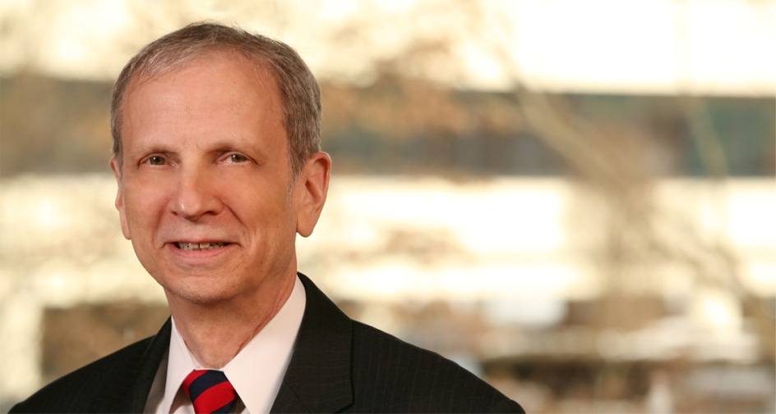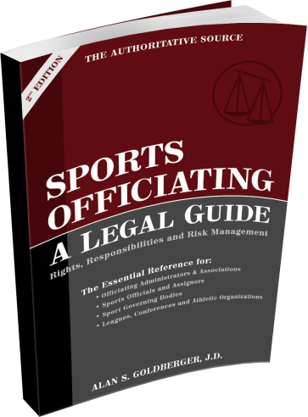

**Alan Goldberger** delivers presentations on sports and “the law” to officials, coaches, athletic administrators, and those who play and enjoy sports everywhere -- informing and educating audiences in terms we can all understand. Renowned for his humorous delivery, he has the talent to captivate and entertain any group. Alan involves himself with the audience creating an interactive atmosphere that keeps everyone on the edge of their seats.

WHEN IT COMES TO THE LEGAL ISSUES IN SPORTS OFFICIATING, THIS MAN WROTE THE BOOK

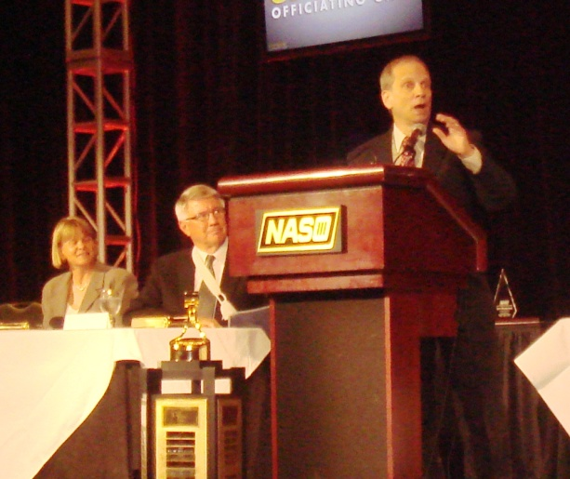

**OFFICIATING AND THE LAW**

Bring your officials up to speed with the best practices in officiating — designed to manage your exposure to liability by helping them keep the game safe, fair and fun! Alan Goldberger's presentations on safety, liability and risk management for sports officials and their associations have been widely acclaimed throughout the country. Workshops can be tailored for your sport, for multi-sport officiating, and for officials’ associations — for topics ranging from "Managing an Officials' Association Today" to "Defending Your Referees" to "Risk Management and Liability in Officiating." The material in these seminars can be put to use starting with your next officiating assignment, contract negotiation or executive committee meeting.

**“*I'D HAVE TO BE UNCONSCIOUS*!” OFFICIATING THE NEW CONCUSSION RULES**

**Concussion in sport**: Over the past few years, every state has enacted laws dealing with it. Playing rules often reference it. Governing bodies publish protocols. Still, down on the dusty playing field, or on the “hardwood” — it is the officials who are often charged with the task of making sure a potentially concussed athlete comes out of the game and does not return to play unless and until he or she can do so safely.

If you supervise, assign or hire referees or umpires, you need to give your officials the mechanics that will enable them to officiate the new playing rules regarding concussion… to effectively manage the risk!

SAFETY AND LIABILITY FOR COACHES, PHYSICAL EDUCATION TEACHERS, ATHLETIC ADMINISTRATORS

Alan Goldberger uses a practical — not theoretical — approach to the challenges faced by athletic coaches, administrators, athletic trainers, physical education teachers, recreation professionals and staff on a daily basis. Presentations and workshops are geared to providing practitioners with a succinct overview of the law of negligence and other aspects of the law affecting participation in sports and athletics.

Alan Goldberger has trained thousands of coaches, administrators, recreation professionals and students, in legal principles related to sport and physical activity. As a practicing attorney, he offers practical techniques and solutions based on his knowledge of the law and his extensive experience as a high school and college referee and umpire.

**IS *YOUR* STAFF AWARE OF HOW THEIR LEGAL RIGHTS AND RESPONSIBILITIES ARE AFFECTED BY THESE STATE LAWS?**

*TORT IMMUNITY ▪ ATHLETIC CODES OF CONDUCT ▪ CONCUSSION ▪*

*TRASH TALKING ▪ ASSAULT/BULLYING ▪ SPORTS AGENTS* ▪ *COACH/OFFICIAL/ATHLETIC TRAINER LICENSING*

**A FEW OF ALAN’S PRESENTATION TOPICS**

To Book Alan: 973.471.9200 • [alan@RefLaw.com](mailto:alan@RefLaw.com) • [www.RefLaw.com](http://www.RefLaw.com)

**ALAN GOLDBERGER**

**Attorney • Speaker • Author Referee/Umpire**

A nationally recognized authority on sports law and sports officiating, Alan is the author of "Sports Officiating: A Legal Guide," the recognized legal authority for game officials. He has been a featured speaker at many national and regional conferences, including the National Association of Sports Officials, International Association of Approved Basketball Officials, American Bar Association, National Intramural Recreational Sports Association, National Parks and Recreation Association, Professional Association of Volleyball Officials, Police Athletic League, US Lacrosse, New Jersey Council of Administrators of Health and Physical Education, Athletic Trainers Society of New Jersey, Atlantic 10 Conference/Patriot League Basketball Officials Developmental Camp, and state high school athletic associations, colleges, universities, and school districts throughout the country. Alan is a practicing attorney and former college basketball official, baseball umpire, and high school football official.

linkedin.jpgtwitter.jpgfacebook.jpg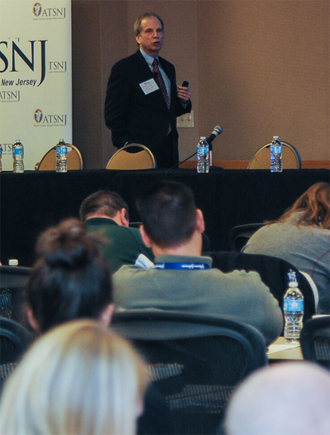

Alan frequently provides legal commentary to national media including…

CBS This Morning® • The New York Times®

USA Today® • Fox News® • NewsOK® • NJBIZ®

Fox & Friends® • New Jersey Law Journal®

Athletic Business® • REFEREE Magazine ®

*Great talk last night, Alan! You're a gifted and engaging presenter!*

*On behalf of the more than 200 officials and staff members at the Camp, I wish to extend our sincere appreciation for your presentations. Our officials were extremely enthusiastic about the information, your candor, and your wit. Today's world forces each and every one of us to focus on safety, respect, diligence, awareness, and prevention. You certainly brought this to the forefront. It is my hope that we can make this an annual event... Thanks for an outstanding and effective presentation.*

*You were such a hit, so personable, and always patient with the questions and comments. I heard so MANY positive comments from attendees. Thanks so much!!*

*Thank you for your great session. I had many comments appreciating your humor and easy conversational style when presenting such an important topic. Thanks again.*

*Our folks were so impressed with your information, but mostly about your delivery!!! It was terrific to have you on hand at our Board meeting - a big plus and so needed.*

*The NASO attorney, Alan Goldberger, once again presented an insightful and often hilarious look at the legal environment for officials.*

*Your presentation was excellent and generated a lot of comment. We have already been asked if you will be back next year to delve further into areas of officiating where your unique expertise and experience can be of great import to our officials.*

*Great speaker... Superb!! Extremely knowledgeable... Nice job helping us understand when we might be liable for the participants... This was by far one of the best sessions. Really addressed real issues.*

*Well prepared, well executed presentation and responses... A lot of really good ideas about things we don't usually want to think about... this session is the most important here... This is needed for everyone.*

*Thank you for providing my teaching staff with a workshop focusing on risk management and liability. It was very well received and all of the teachers had positive comments on your presentation and knowledge of the subject matter. Most importantly, you made it relevant to their duties as teachers and coaches. The teachers also appreciated your input on several of the concerns presented during the workshop. The materials and topics were in direct line with my goals for the day.*

*Alan Goldberger ... had, far and away, the most useful, best organized, and most entertaining presentation of the entire Conference.*

*You are the man! LOVE your presentations!*

*You were the BEST presenter there! REALLY! I loved your comic timing! Thanks for being so dedicated to officials. You are doing important work and I appreciate you.*

**BOOK ALAN TODAY**

**SOCIAL MEDIA**

973.471.9200

201.755.6800

[speak@RefLaw.com](mailto:speak@RefLaw.com)

[www.RefLaw.com](http://www.RefLaw.com)

P.O. Box 447

Summit, NJ 07902

973.836.0201

[Alan Goldberger](https://www.linkedin.com/in/alangoldberger)

[@alangoldberger](https://twitter.com/alangoldberger)

[SPORTS OFFICIATING: A LEGAL GUIDE](https://www.facebook.com/pages/SPORTS-OFFICIATING-A-LEGAL-GUIDE-2nd-Edition-by-ALAN-GOLDBERGER/106393112722484?fref=ts)

[2nd Edition, by ALAN GOLDBERGER](https://www.facebook.com/pages/SPORTS-OFFICIATING-A-LEGAL-GUIDE-2nd-Edition-by-ALAN-GOLDBERGER/106393112722484?fref=ts)

**IN THE MEDIA WHAT OTHERS ARE SAYING**